**CREATE A CLOUD OBJECT STORAGE SERVICE**

|  |  |
| --- | --- |
| DATE | 15-NOV-2022 |
| TEAM ID | PNT2022TMID33663 |
| PROJECT NAME | IOT Based Smart Crop Protection  System for Agriculture |

**Step 1**: Enter your IBM cloud account credentials.

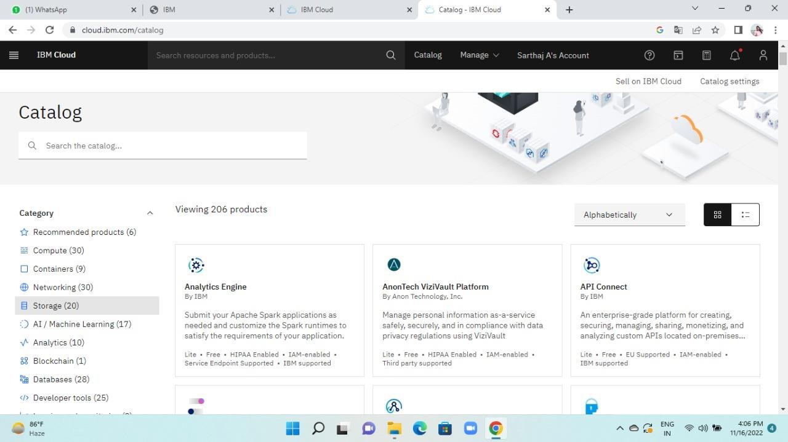

**Step 2**: open the catalog. then click on the storage.

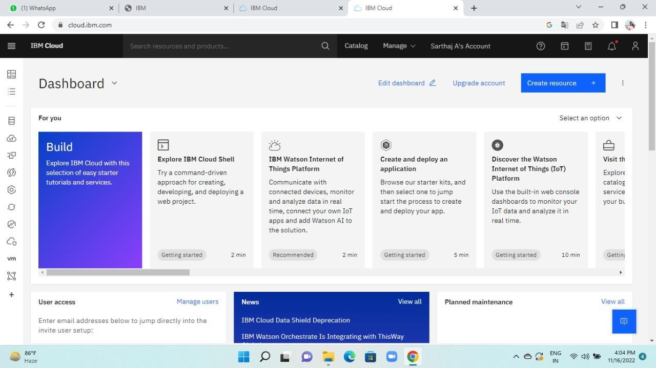

**Step 3** : Then if you scroll down you observeobject storage and click on it.

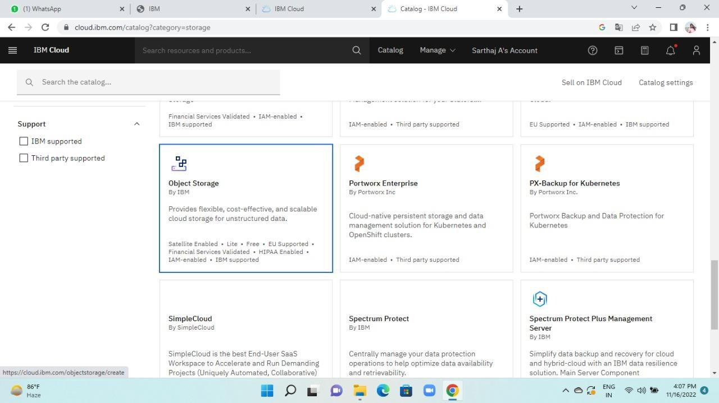

**Step 4** : Then it will open like in the below andclick on create to create the cloud object storage.

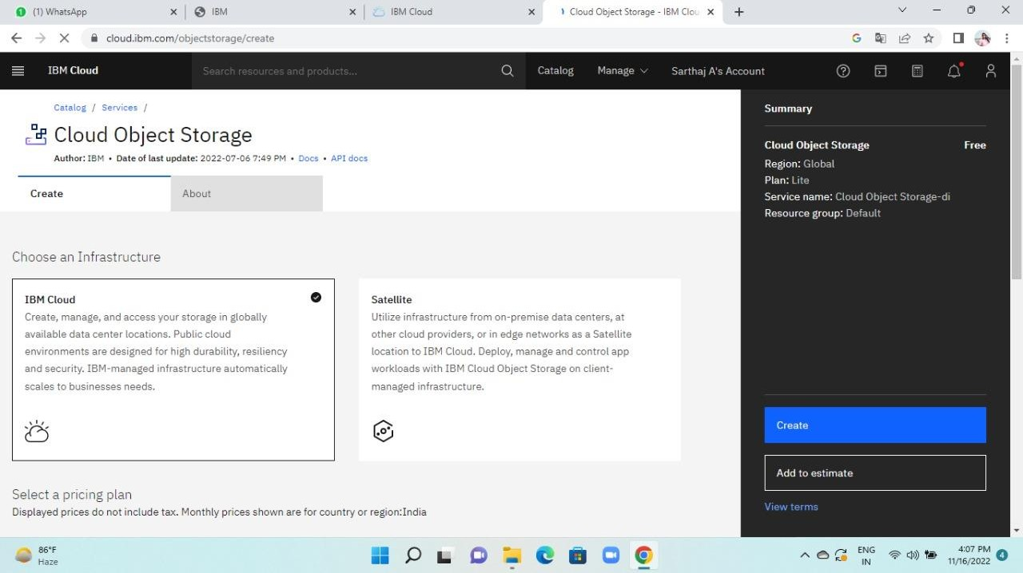

**Step 5** : Therefore creation of cloud objectstorage is created.

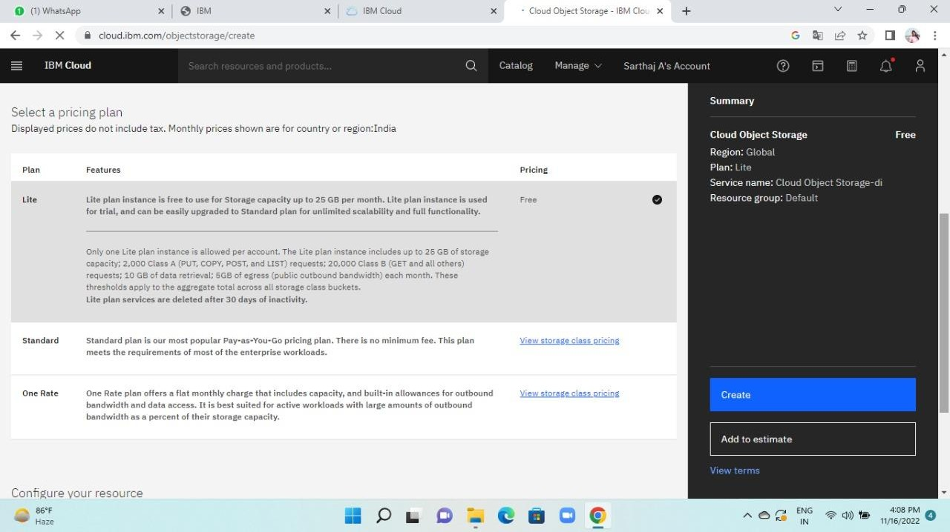

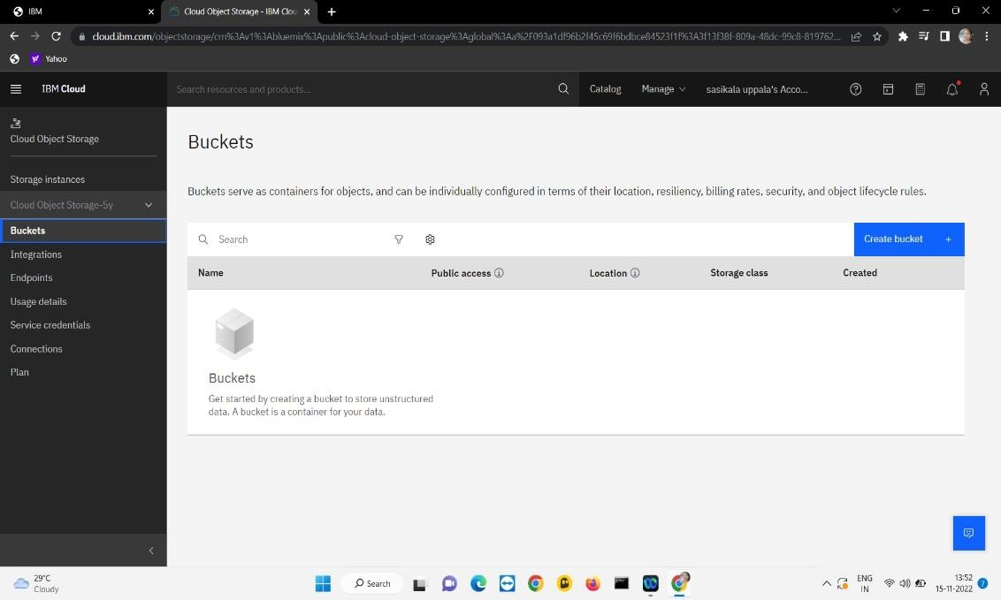**Step 6** : We need to establish a bucket to store the image. Clicking on it will display a few options for creating buckets. Selecting a custom bucket will open as seen below. Enter the information requested, then click the Create Bucket button.

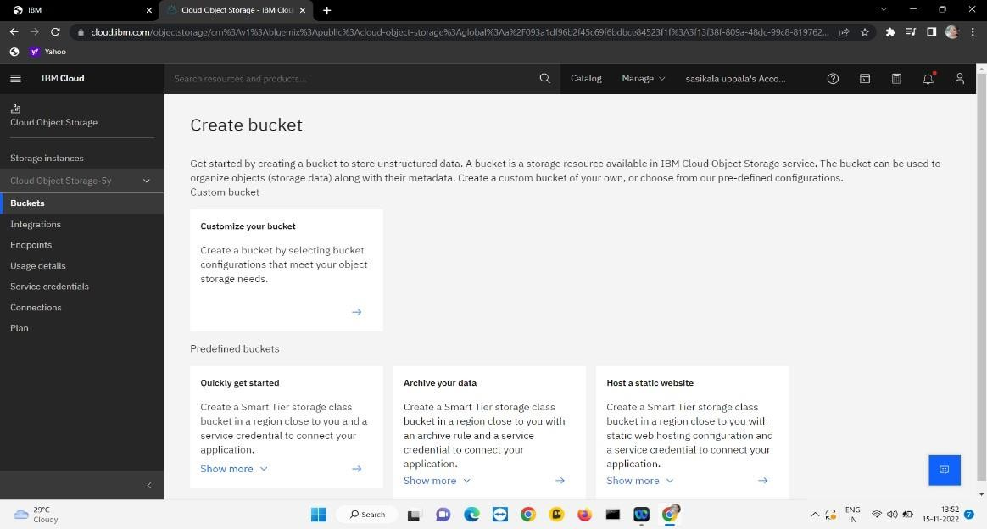

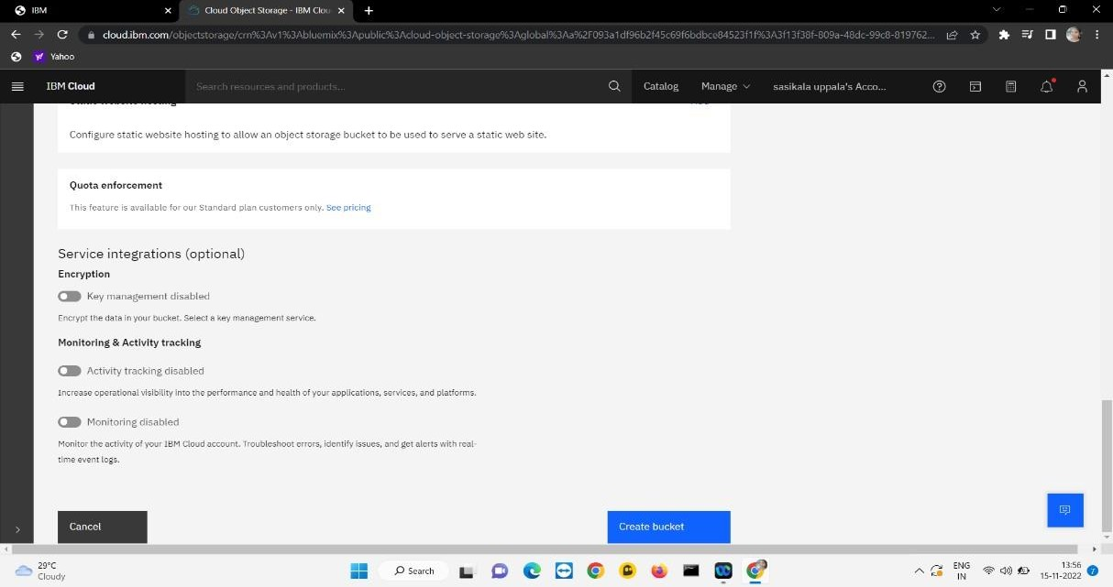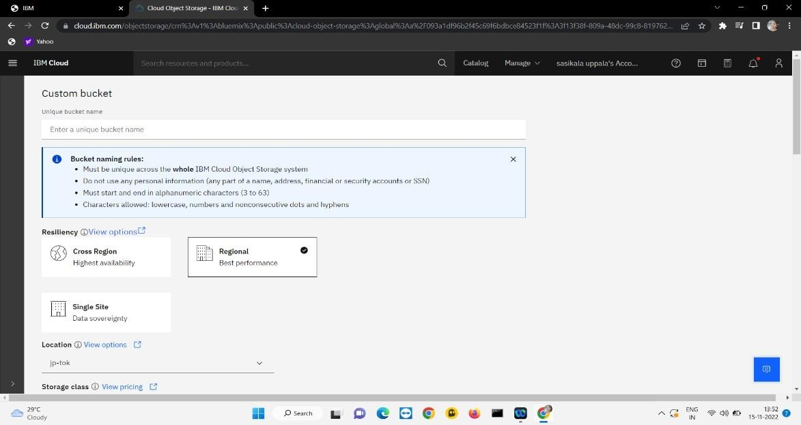

**Step 7** : Then you get observe bucket is created successfully. And to store the images drag anddrop files shown in below picture.

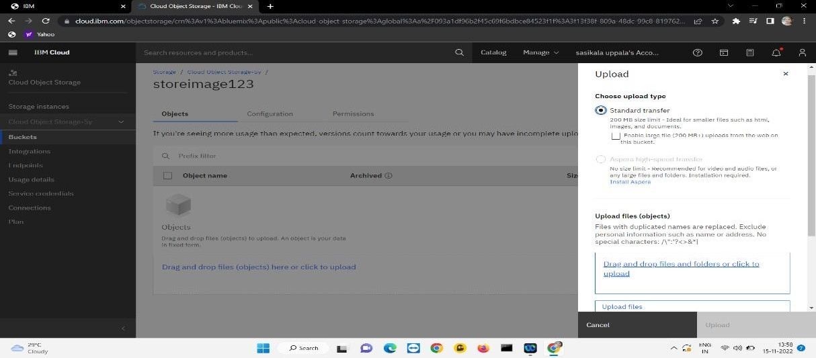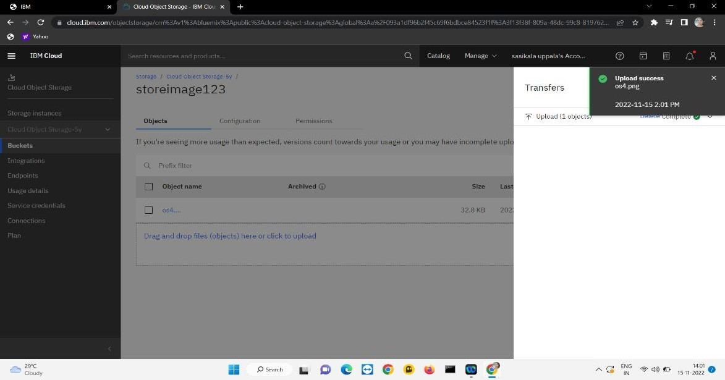

**Step 8**: Now you can see observe configurationsettings as shown.

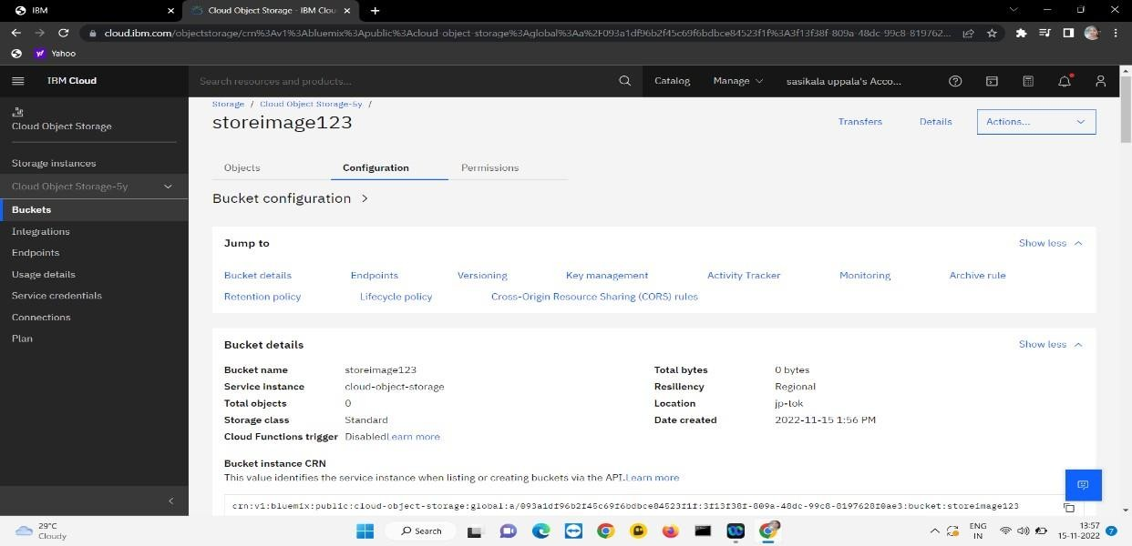

**Step 9**: Here you can see the endpoints which isused for programming.

**Step 10**: The important part is service credentials for programming integrity.

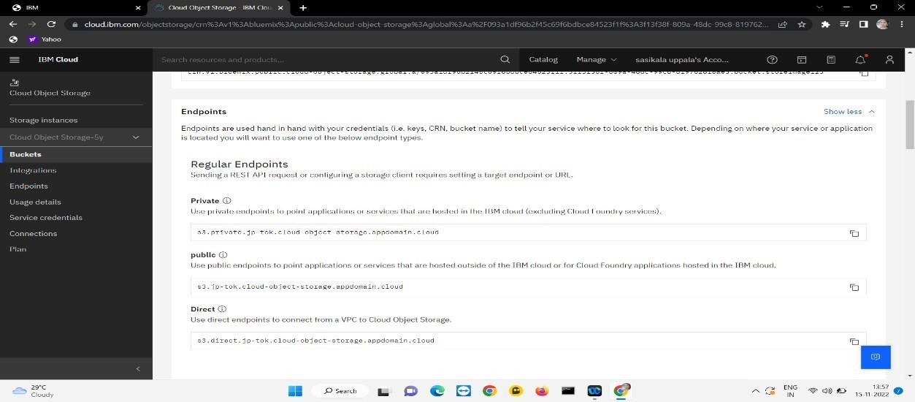

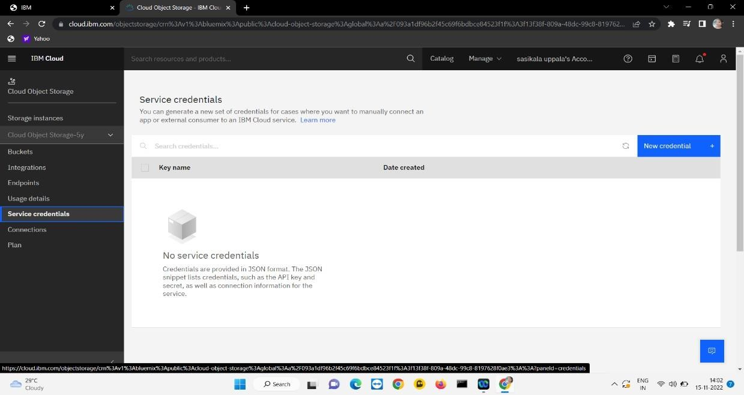

Now click on create credential then you get thisthe figure below and remember those for programming.

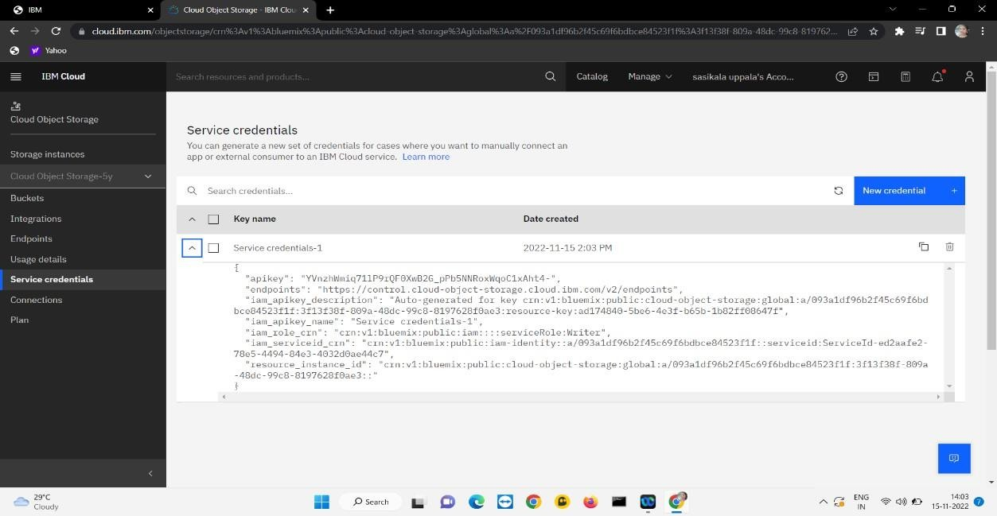

**Step 11**: Hence like this you can create a cloud object storage service, create a bucket to store the images, and configure the bucket settings.